Followers  83,481  13,174  9,553  1,740  Total 107,948 |  | Engagement  Instagram  Average like per post 3,397.3  Average comment per post 72.8  engagement rate 3.75%  new follower per week 600  Facebook  61% Female  38% male  Top Cities: Knoxville, Honolulu, Chicago, New YOrk  Top Countries : USA, Canada, Germany  Twitter  48% Male  53% Female  top interest: dogs, comedy, sports  40% of audence makes over $100,000  know for online buying

Instagram Growth in the Last 2 years (+70,000)
Instagram Followers in the last year (+35,000)
Instagram Increase in Likes/Comments 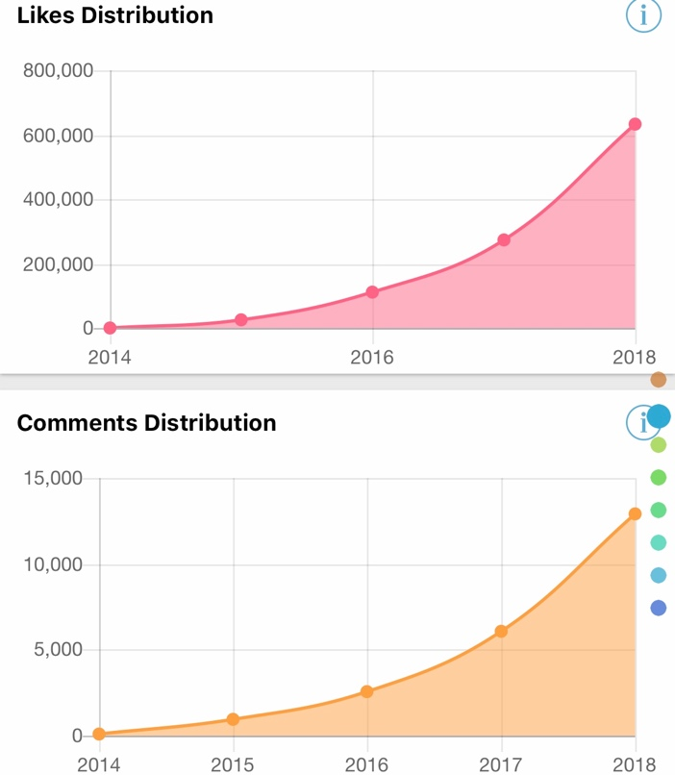
Instagram Likes/Comments per post increase 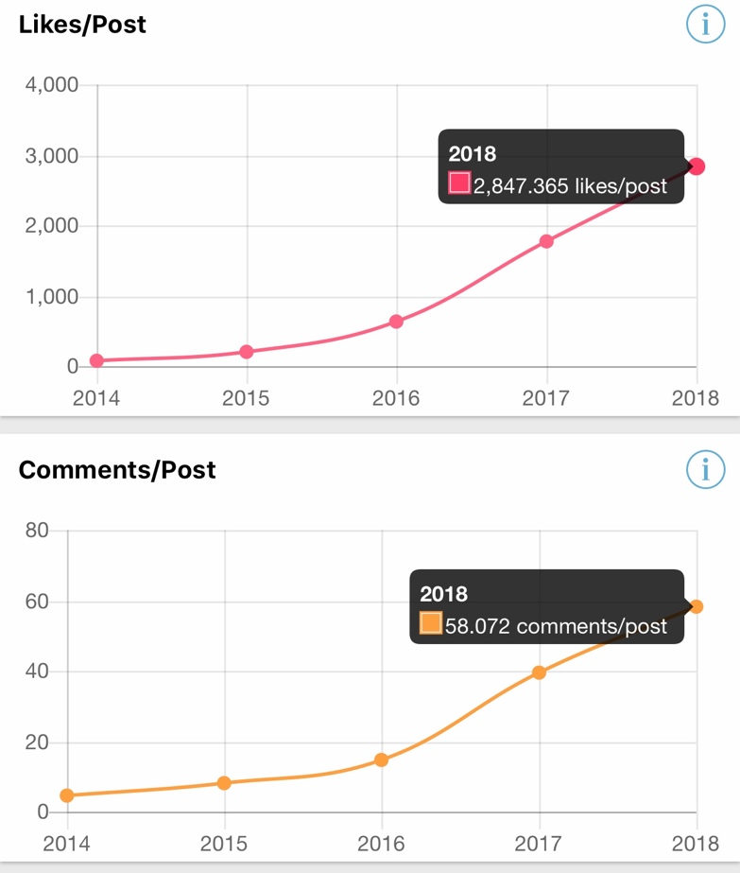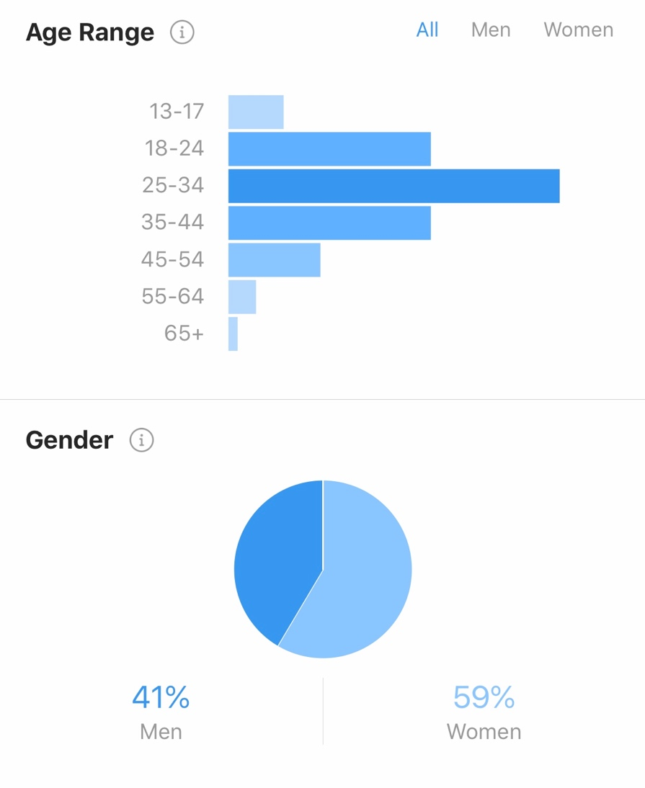
Facebook followers
